**FACTORY METHOD PATTERN**

Document.java

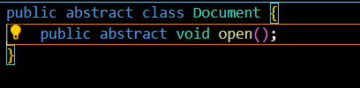

DocumentFactory.java

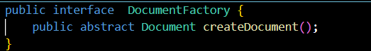

ExcelDocument.java

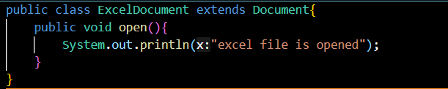

ExcelFactory.java

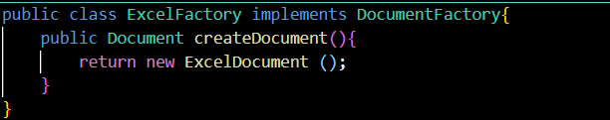

pdfDocument.java

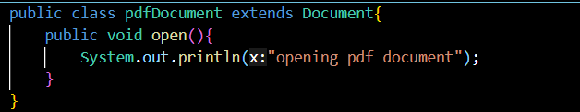

pdfFactory.java

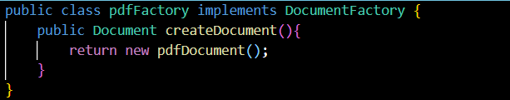

wordDocument.java

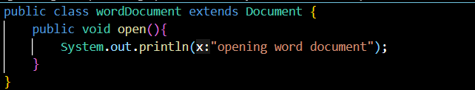

wordFactory.java

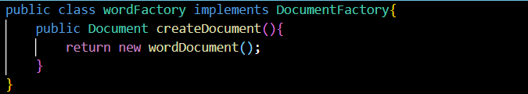

MainFile.java

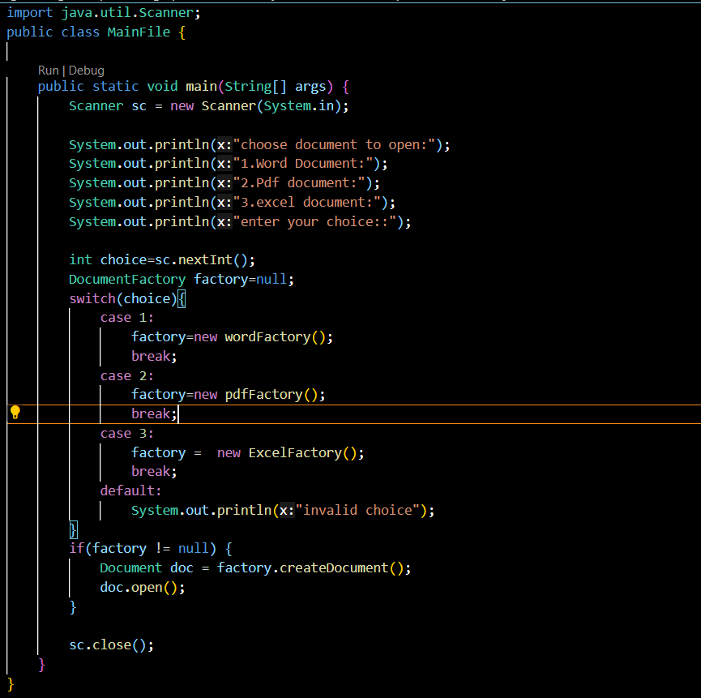

**OUTPUT**

